 | SR UNIVERSITY  Campus Warangal
 | Program: II - B. Tech (CS& AI) Batch:
 | Name: k.Neshwanth Reg. No:2503a52315
 | Department: Computer Science and AI Semester: I
 | AI Assisted Coding-Assignment Date: 21/09/2026

Question
Problem
A hospital has a hierarchical structure. Represent the following using a Tree:
Hospital
├── Cardiology
│ ├── ICU
│ └── General Cardiology
├── Neurology
│ ├── Stroke Unit
│ └── Neuro ICU
└── Orthopedics
Requirements
Create tree nodes.
Add child departments
Display the hierarchy.
Search for a department.
Count total departments.
Test at least three search cases.

Prompt
Create a Python tree structure to represent a hospital department hierarchy.
The hierarchy is:
Hospital
├── Cardiology
│ ├── ICU
│ └── General Cardiology
├── Neurology
│ ├── Stroke Unit
│ └── Neuro ICU
└
── Orthopedics
Implement the following:
1. Create tree nodes.
2. Add child departments.
3. Display the hierarchy.
4. Search for a department.
5. Count the total number of departments.
6. Test at least three search cases.
Use simple and beginner-friendly Python code and display the output clearly.

Code
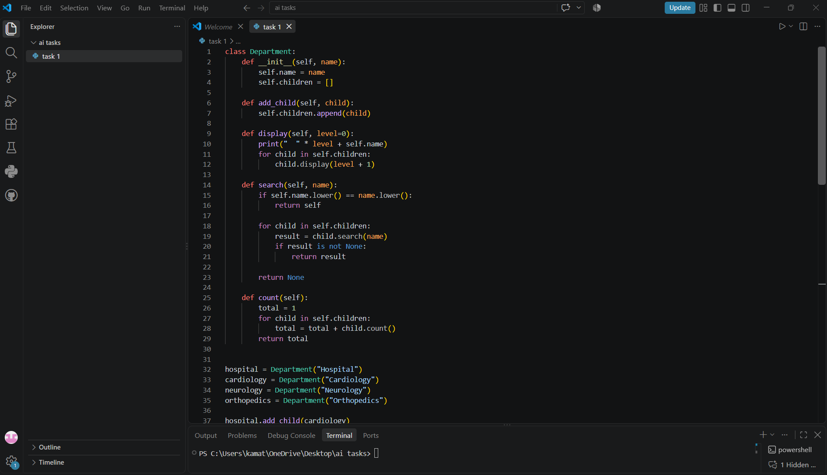
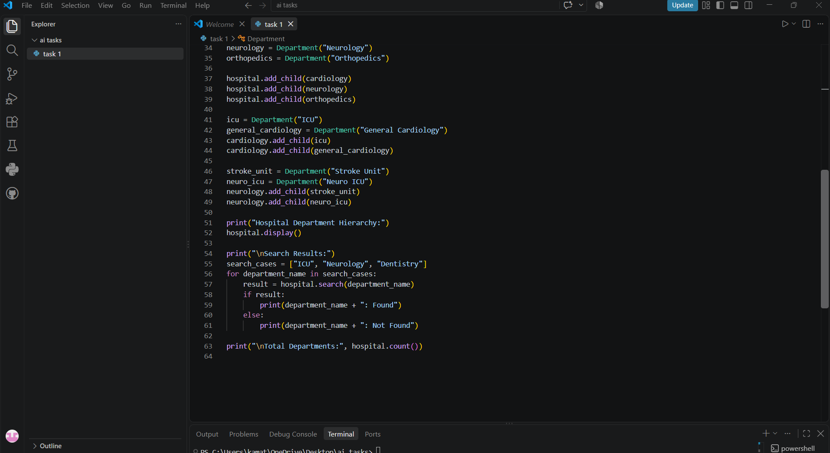

Output
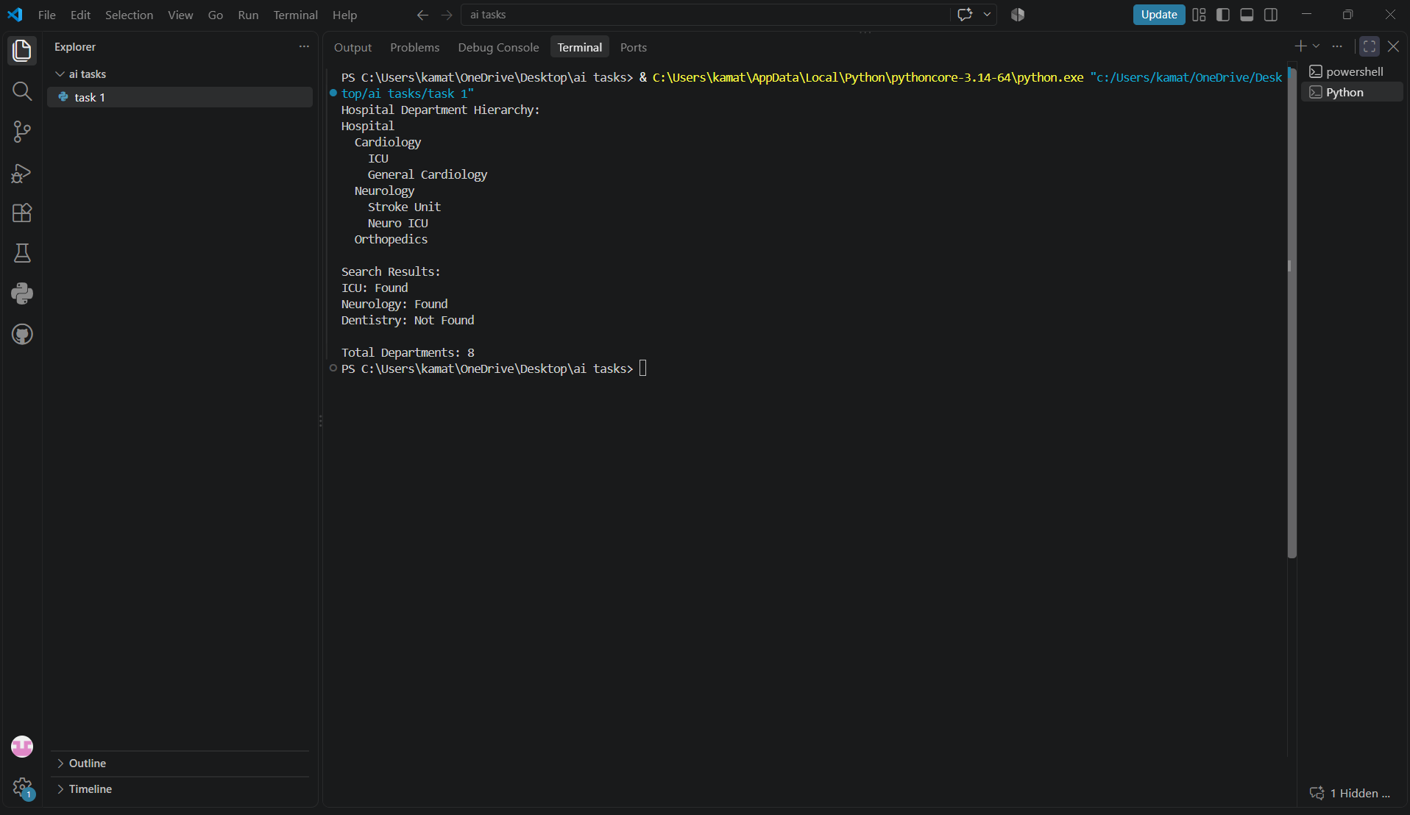
Observation
The hospital department hierarchy was successfully represented using a Tree data structure. Each department was created as a tree node, and child departments were added under their respective parent departments. The program successfully displayed the hierarchy, searched for departments, and counted the total number of departments. Three search cases were tested, including both existing and non-existing departments. The task demonstrates that a tree is suitable for representing hierarchical relationships.

The hospital department hierarchy was successfully represented using a Tree data structure. Each department was created as a tree node, and child departments were added under their respective parent departments. The program successfully displayed the hierarchy, searched for departments, and counted the total number of departments. Three search cases were tested, including both existing and non-existing departments. The task demonstrates that a tree is suitable for representing hierarchical relationships.

Question
Problem
Represent hospital locations as a Graph. Each location is a node and each connection is an edge.
Reception ─── Pharmacy
│ │
│ │
ICU ─────── Emergency
│
Laboratory
Requirements
Add hospital locations as nodes.
Add connections as edges.
Display the graph using an adjacency list.
Check whether two locations are connected.
Find a route using BFS or DFS.
Test at least three source-destination pairs.

Prompt
Create a simple Python graph representing hospital locations.

The locations are:
Reception, Pharmacy, ICU, Emergency, and Laboratory.

Create the following connections:
Reception - Pharmacy
Reception - ICU
Pharmacy - Emergency
ICU - Emergency
ICU - Laboratory

Implement:
1. Adding locations as nodes.
2. Adding connections as edges.
3. Displaying the graph using an adjacency list.
4. Checking whether two locations are connected.
5. Finding a route between two locations using BFS.
6. Testing at least three source-destination pairs.

Use simple beginner-friendly Python code and display the output clearly.
Code
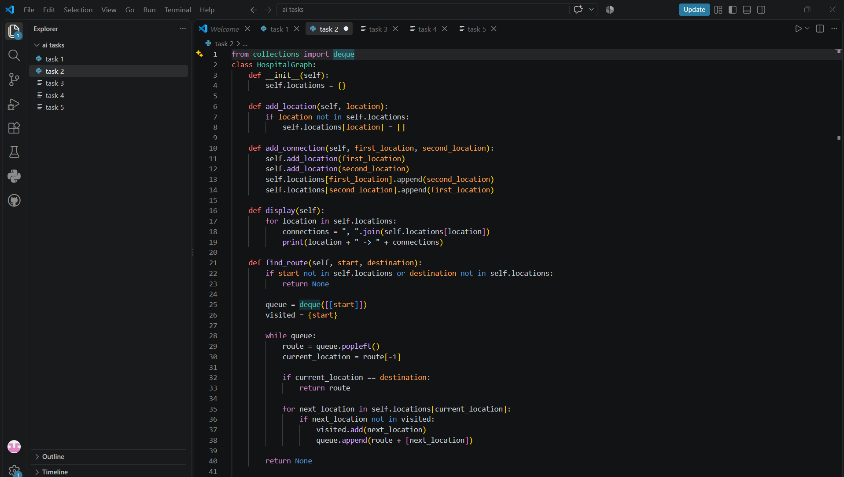
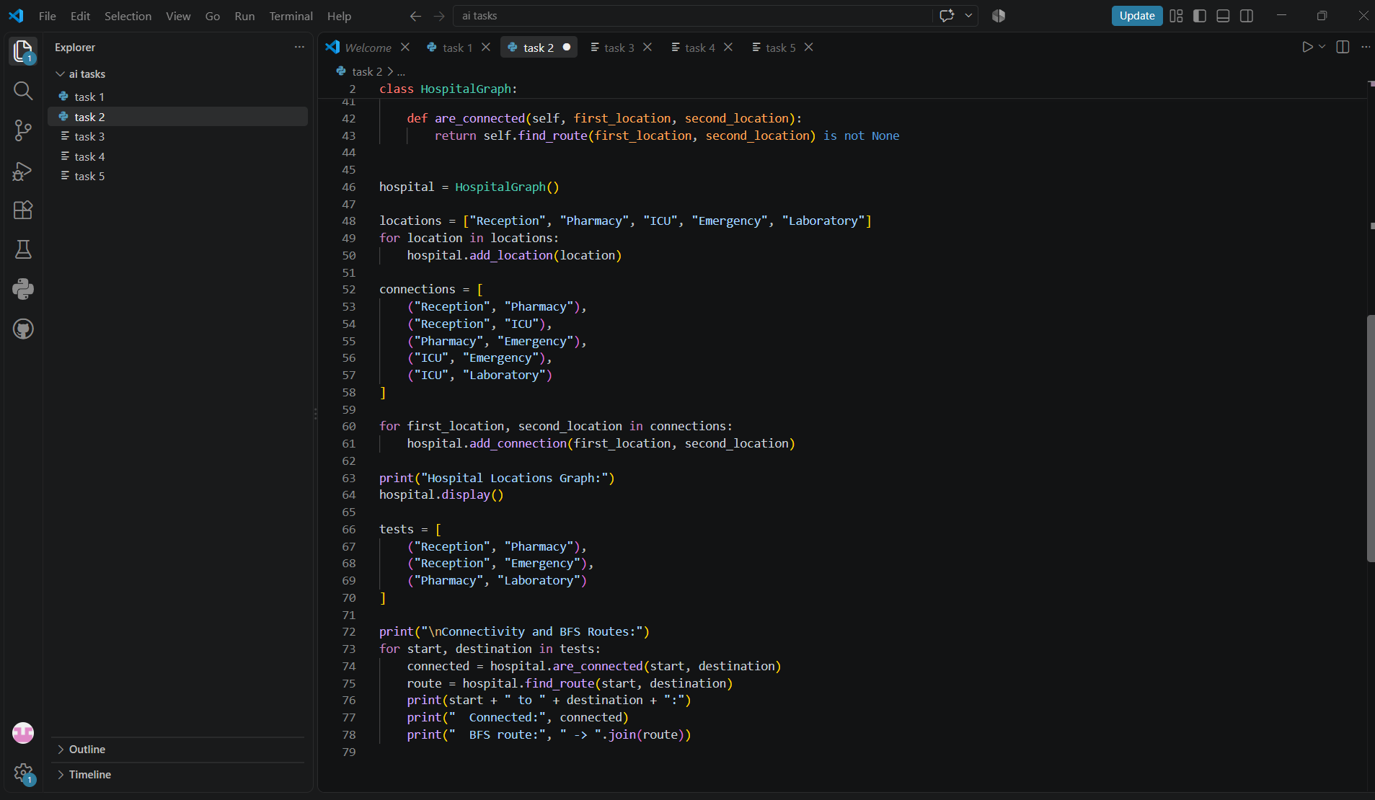

Output

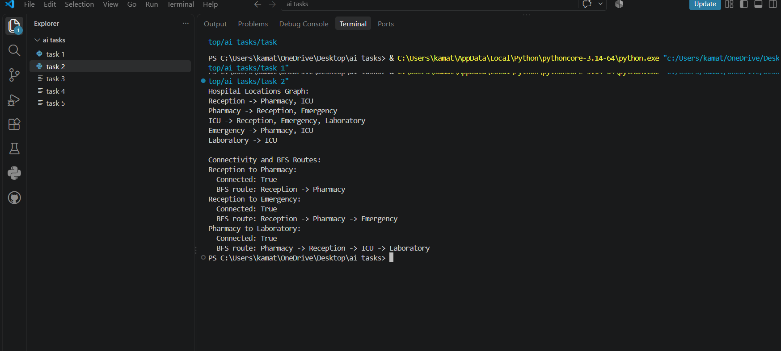

Observation
The hospital locations were successfully represented using a Graph data structure. Each hospital location was represented as a node and the connections between locations were represented as edges. The graph was displayed using an adjacency list. BFS (Breadth-First Search) was used to find routes between different hospital locations, and three source-destination cases were tested successfully.

Question
Problem
In an emergency department, patients are treated according to severity rather than simple arrival order. Implement a Priority Queue using a Heap.
Priority 1 → Critical
Priority 2 → Serious
Priority 3 → Moderate
Priority 4 → Normal
Requirements
Add a patient with a priority value.
View the highest-priority patient.
Remove/serve the highest-priority patient.
Display waiting patients.
Handle at least one tie in priority appropriately.
Test insertion and removal operations

Prompt
Create a simple Python Priority Queue using a Min Heap for an emergency department.

Use these priorities:
Priority 1 → Critical
Priority 2 → Serious
Priority 3 → Moderate
Priority 4 → Normal

The program should:
1. Add patients with their priority values.
2. View the highest-priority patient.
3. Remove and serve the highest-priority patient.
4. Display all waiting patients.
5. Handle two patients having the same priority.
6. Test insertion and removal operations.

Use Python's heapq module and beginner-friendly code.
Display the output clearly and explain how the heap gives priority to patients.

Code
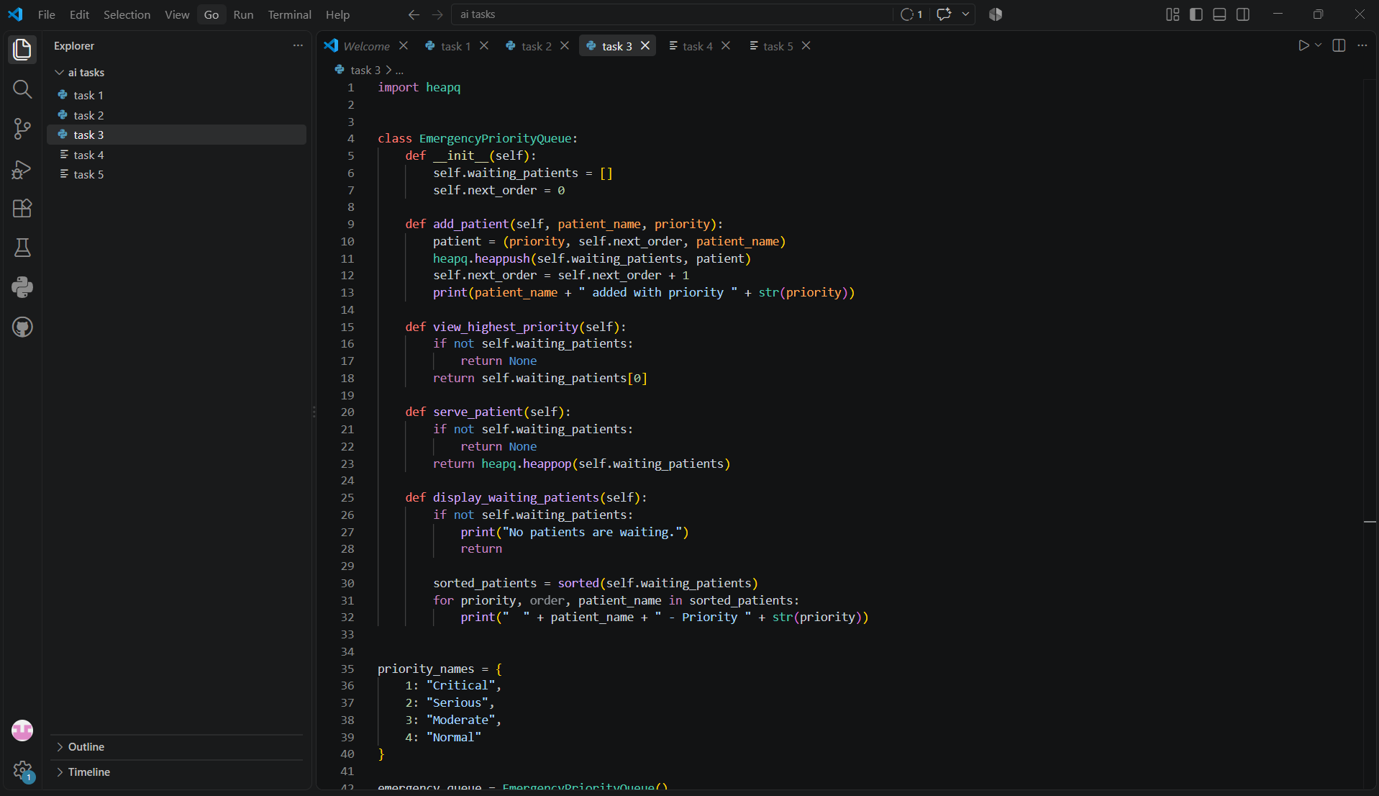
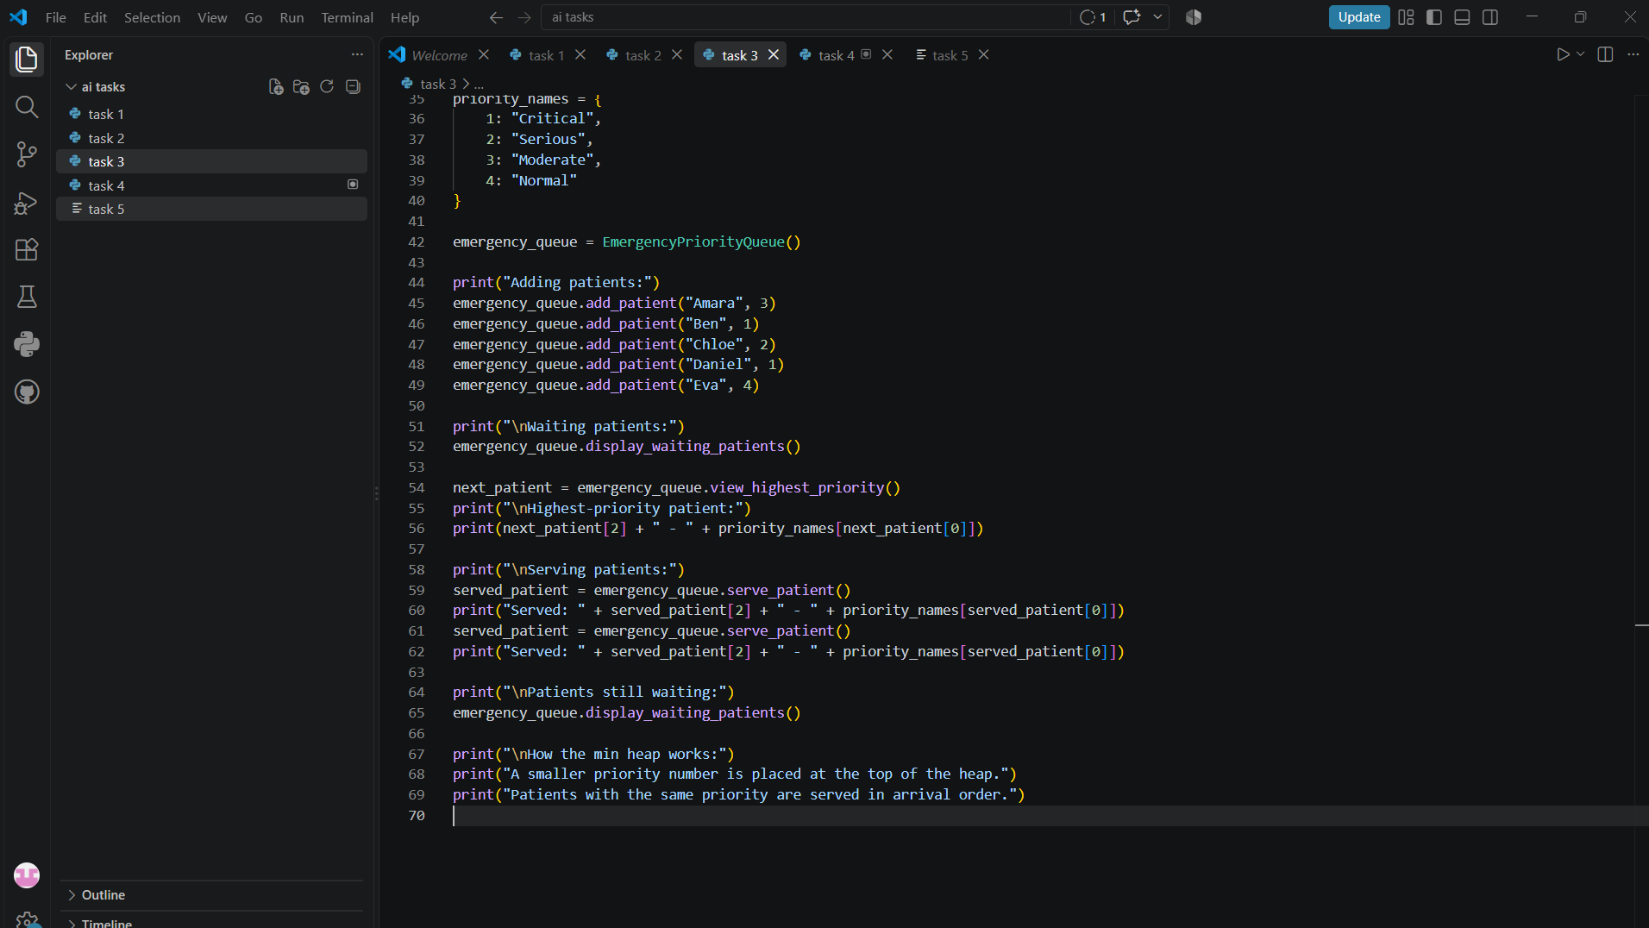

Output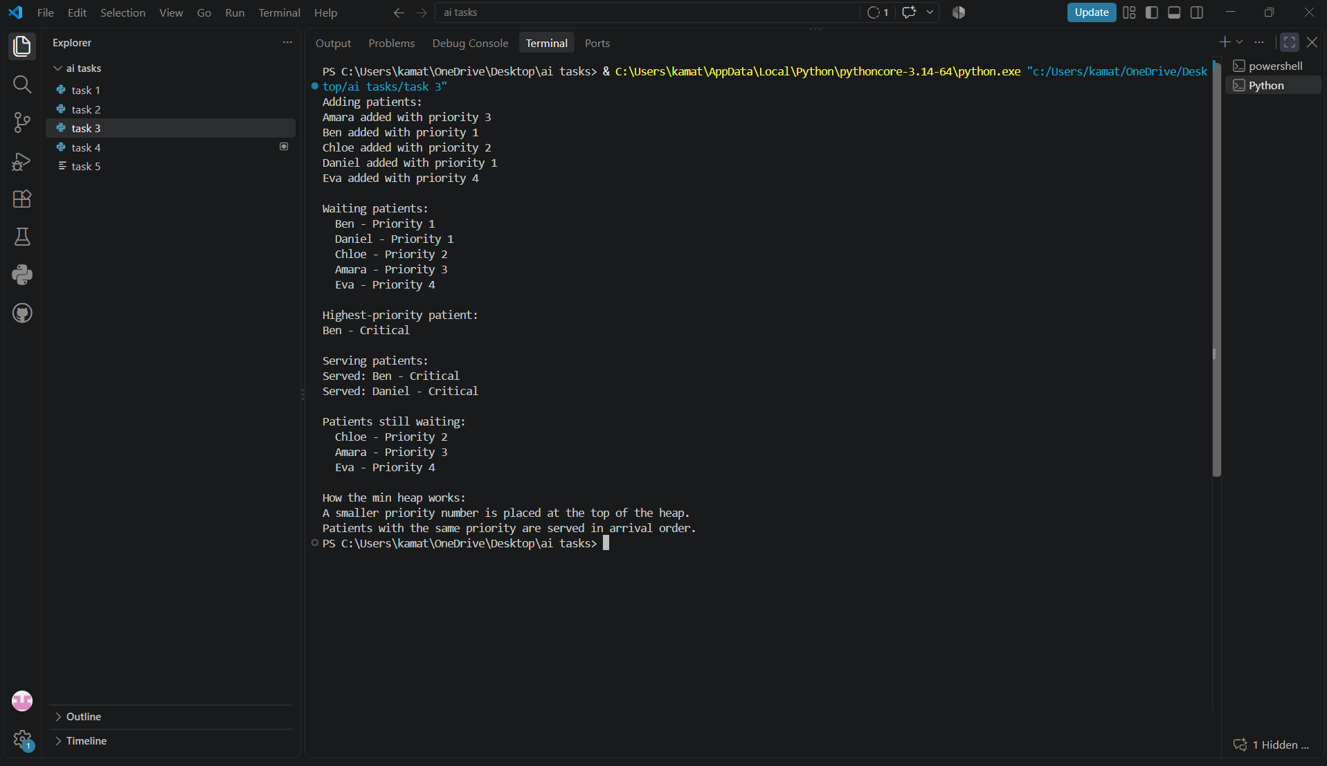

Observation
The emergency patient system was successfully implemented using a Priority Queue with a Min Heap. Patients with a smaller priority number are served first, so Priority 1 (Critical) patients are given the highest priority. The program successfully supports insertion, viewing, and removal of patients. A tie between two Priority 1 patients was also handled by serving them in their insertion order.

Question
A hospital application needs an autocomplete feature. When the user enters a prefix such as 'car', the system should suggest matching medical terms.
Input prefix: "car"
Possible output:
cardiology
cardiac
carcinoma
care
Requirements
Create a Trie.
Insert medical words.
Search for an exact word.
Check whether a prefix exists.
Display/autocomplete words beginning with a prefix.
Test at least three different prefixes

Prompt
Implement a simple Trie in Python for medical-word autocomplete.

The program should:
1. Create a Trie data structure.
2. Insert medical words into the Trie.
3. Search for an exact medical word.
4. Check whether a prefix exists.
5. Display all words beginning with a given prefix.
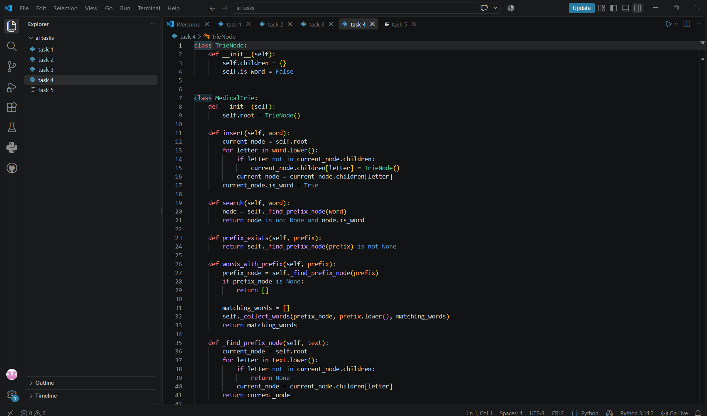6. Test at least three different prefixes such as "car", "dia", and "neuro".

Use beginner-friendly Python code and clearly display the output.

Also explain how a Trie stores characters and why it is useful for prefix searching.
Code

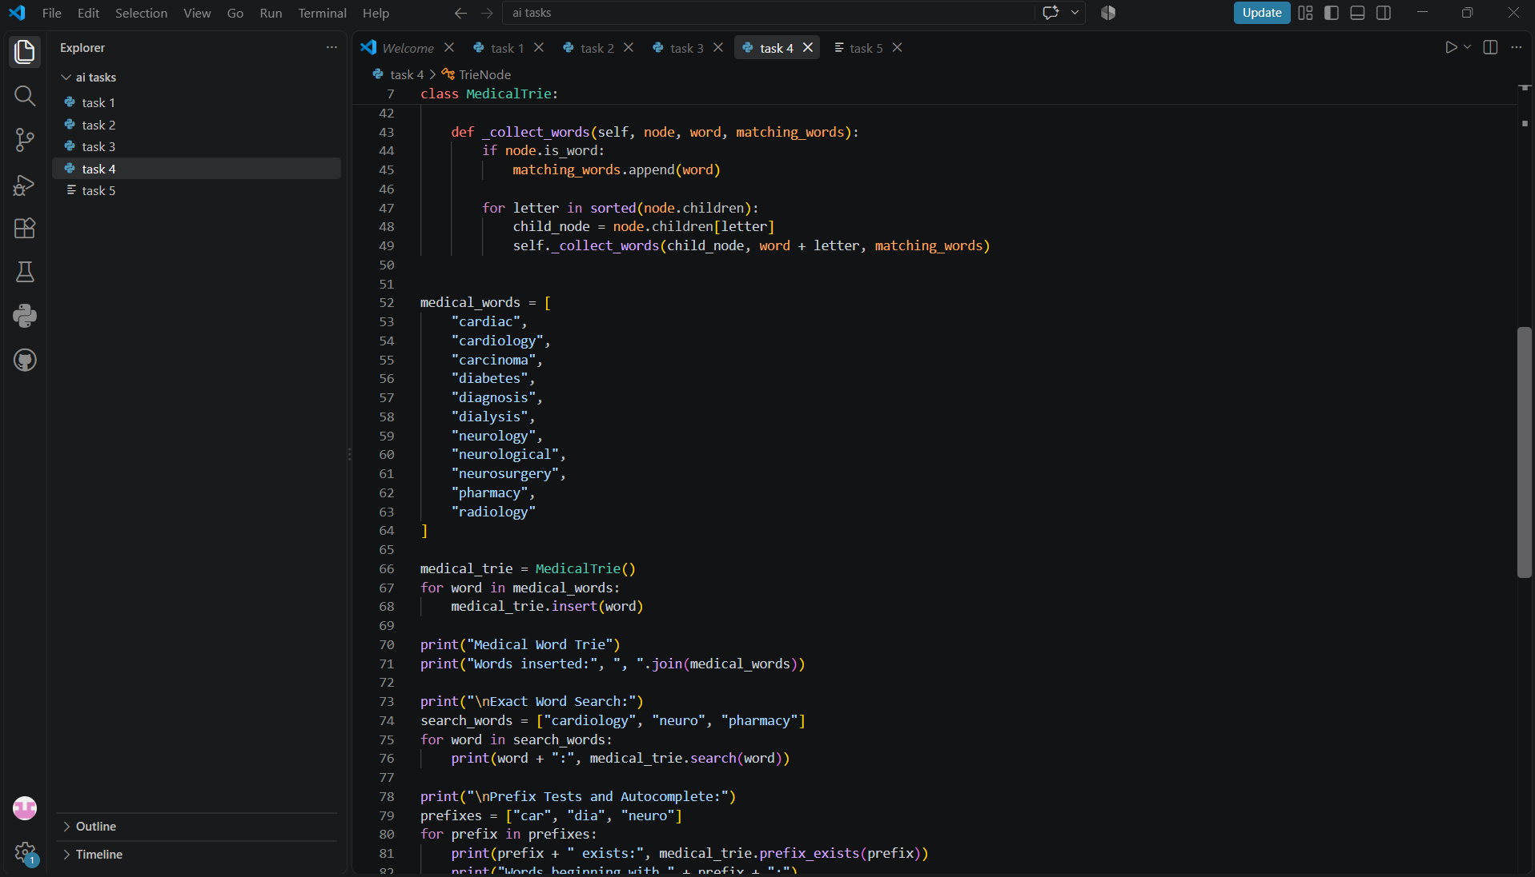
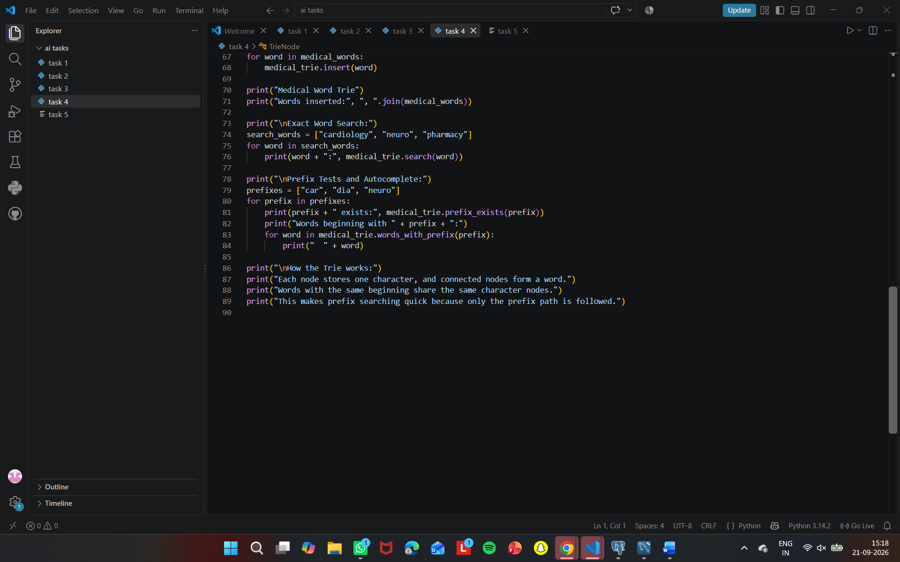

Output
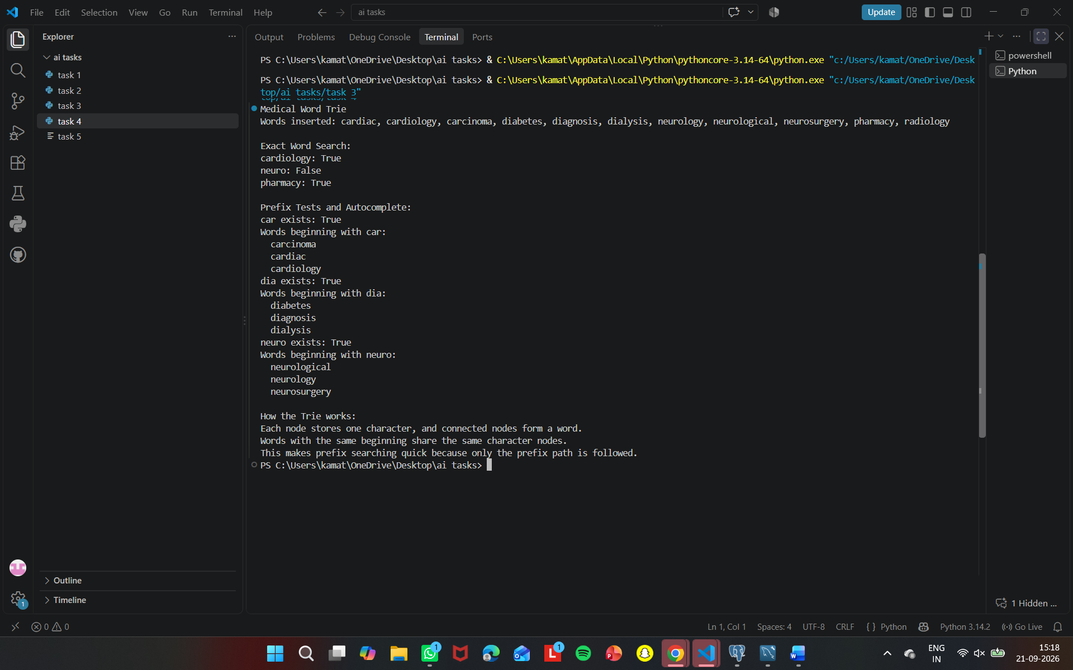

Observation
The medical-word autocomplete system was successfully implemented using a Trie data structure. Medical words were inserted character by character into the Trie. The program successfully performed exact word searching, prefix checking, and autocomplete. For example, entering the prefix "car" produced matching medical terms such as cardiology, cardiac, carcinoma, and care. The Trie is useful for autocomplete because words sharing the same prefix share the same path in the tree.

Question
Structure
For each hospital-software scenario, choose the most appropriate non-linear data structure: Tree, Graph, Heap, or Trie.
Scenario | Your Choice + Reason
Hospital department hierarchy
Finding a route between hospital rooms
Emergency patients based on severity
Autocomplete medical terms
Frequently finding the highest-priority task
Student Activity
Choose the data structure.
Explain why it is appropriate.
Identify the main operation.
State the expected/typical Big-O complexity where appropriate.
Ask AI for a recommendation.
Compare your choice with AI's recommendation.
If you disagree with AI, explain why.

Prompt
For each of the following hospital-software scenarios, choose the most appropriate data structure from Tree, Graph, Heap, or Trie.

Scenarios:
1. Hospital department hierarchy
2. Finding a route between hospital rooms
3. Emergency patients based on severity
4. Autocomplete medical terms
5. Frequently finding the highest-priority task

For each scenario:
- Give the recommended data structure.
- Explain why it is appropriate.
- Identify the main operation.
- Give the typical Big-O complexity where appropriate.
- Present the answer in a simple table.
Code
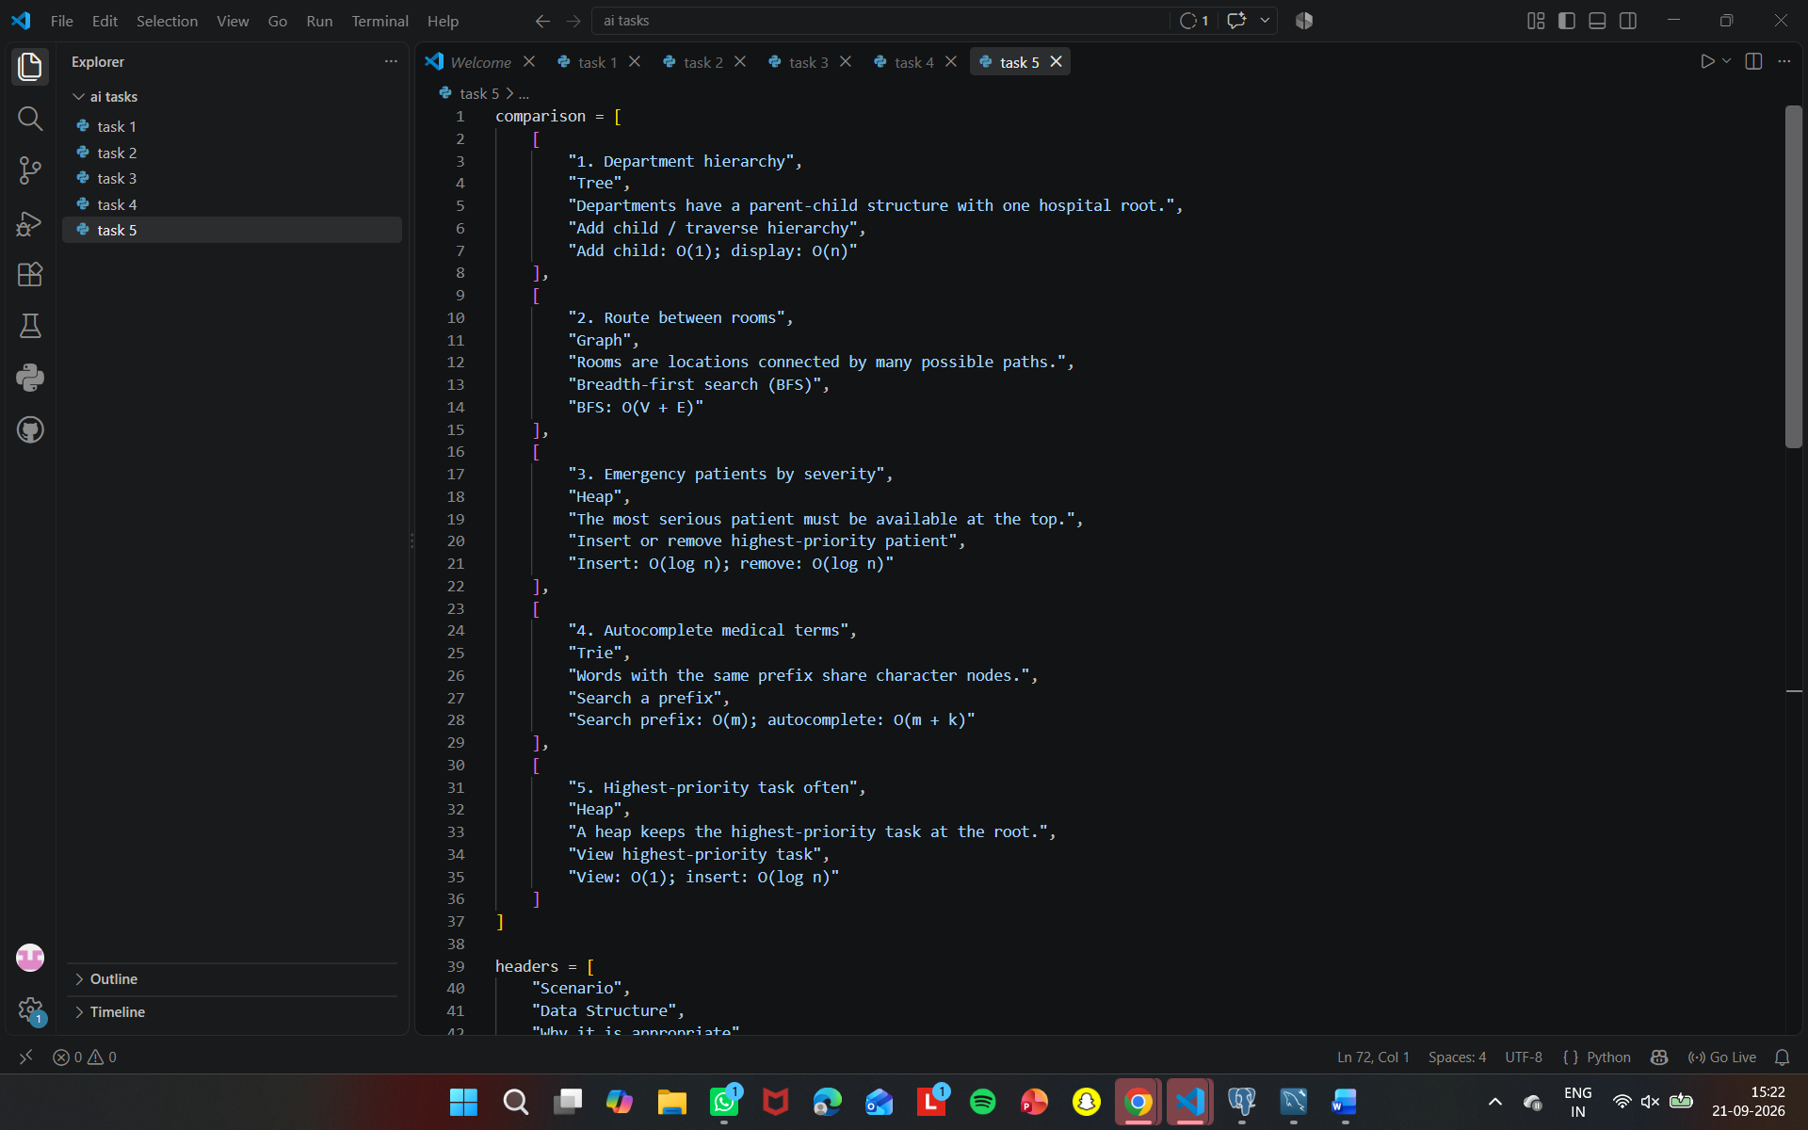
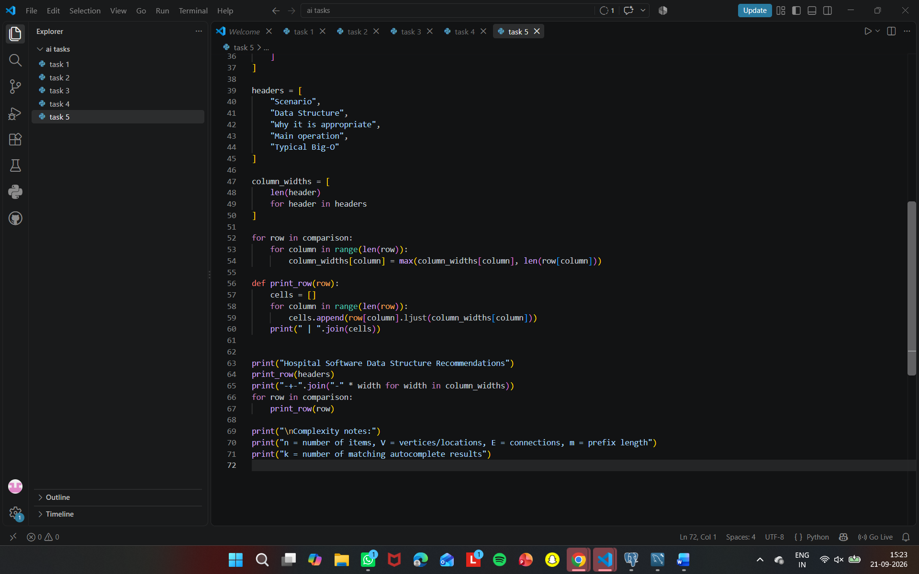
Output
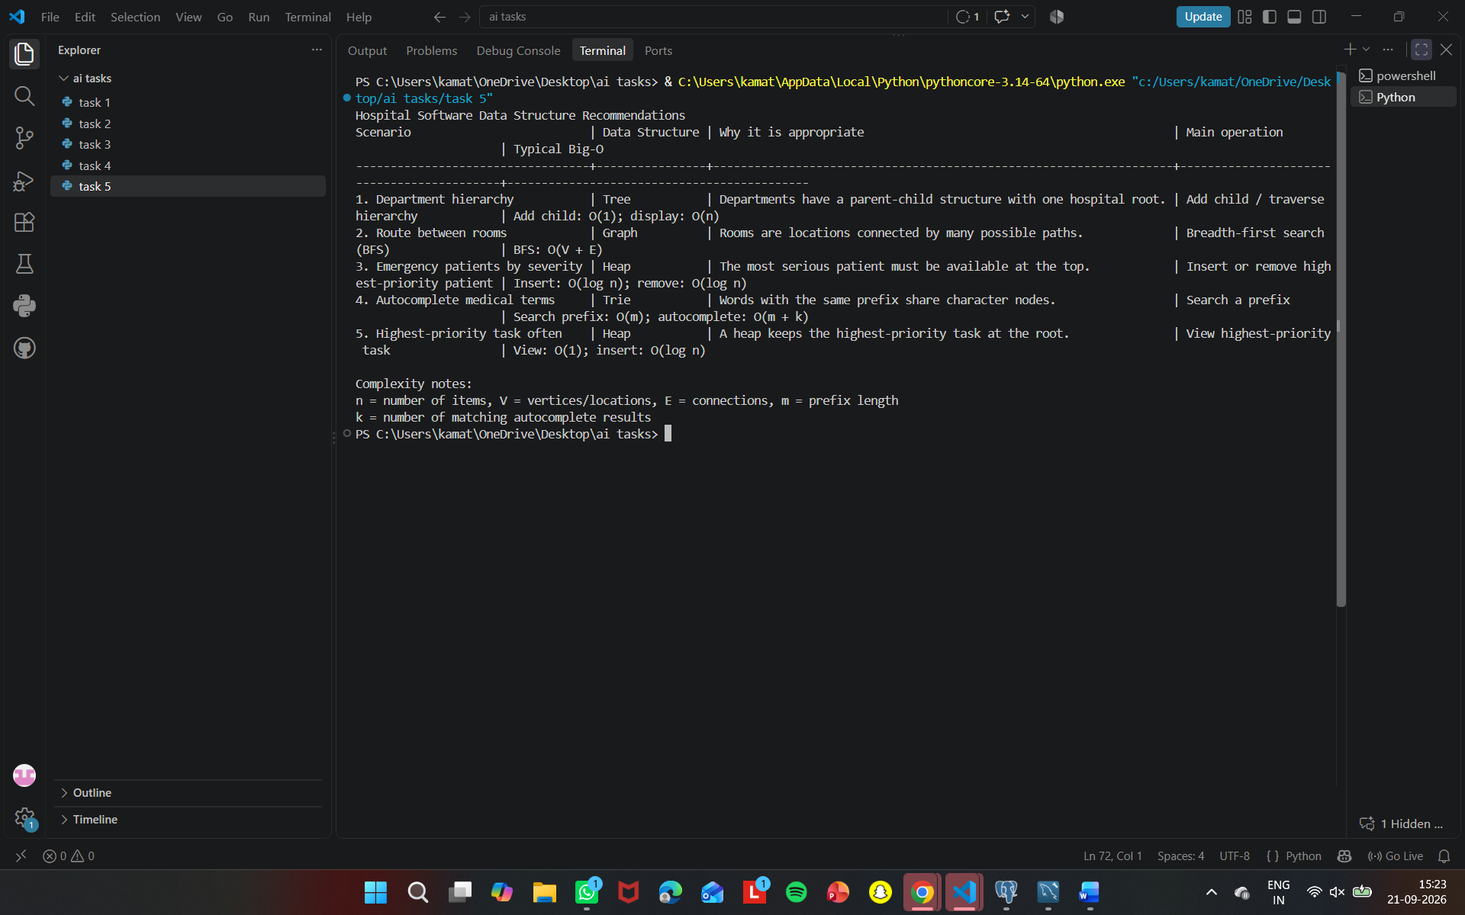
Observation
The task demonstrated that different non-linear data structures are suitable for different hospital-software requirements. A Tree is appropriate for hierarchical departments, a Graph is suitable for routes and connections, a Heap is useful for priority-based tasks, and a Trie is efficient for autocomplete and prefix searching. The AI recommendations matched the selected structures, confirming that the choices were appropriate for the given scenarios.

